So lets check scikit learn implementation of CalibratedClassifiersCV

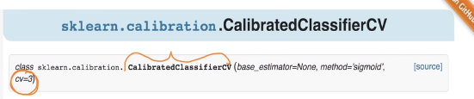

Here CV is the parameters which decides how many cross folds I want.

And base_estimator is the trained model on which we want to perform calibratedclassifierCV.

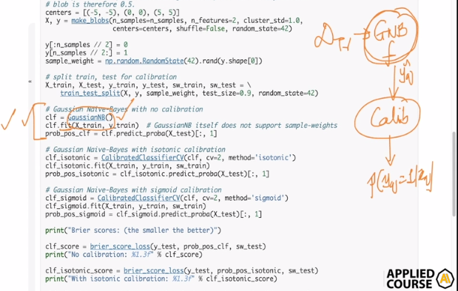

So now when we have trained model on GaussianNB() and its clf

We will form calib and try to predict probabilities for (Yq).

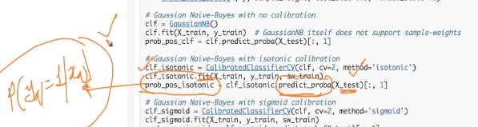

If we want to use sigmoid scaling than just replace ‘isotonic’ in method parameter with ‘sigmoid’.